**Digital Image Processing**

**Title: Edge Detection**

**Tools Used:** Python

**Procedure:** Open IDLE and perform the following tasks

**Task 1**

Read the image below, apply the masks to detect horizontal, vertical and diagonal lines and compare the results of different masks. Below are four different line detection filters.

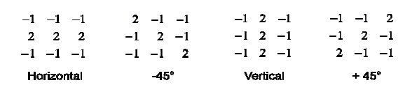

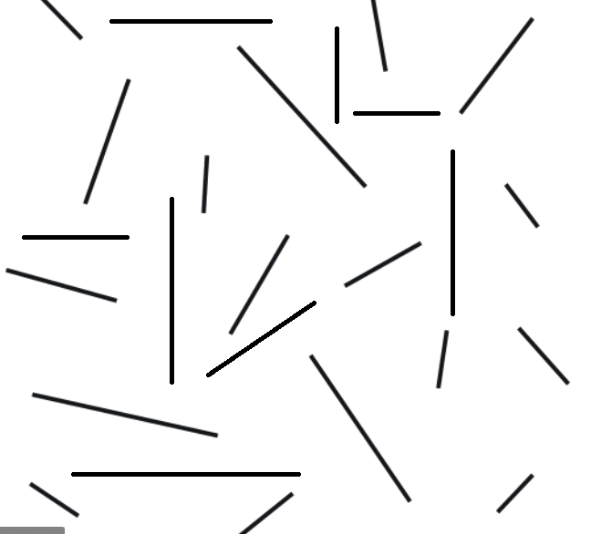

**Procedure:**

import cv2  
import numpy as np  
  
img = cv2.imread("lines.jpeg")  
img = cv2.resize(img, (0, 0), None, .5, .5)  
  
HorizKn = np.array(([[-1, -1, -1], [2, 2, 2], [-1, -1, -1]]), np.float32)  
Ng45Kn = np.array(([[2, -1, -1], [-1, 2, -1], [-1, -1, 2]]), np.float32)  
VertiKn = np.array(([[-1, 2, -1], [-1, 2, -1], [-1, 2, -1]]), np.float32)  
Ps45Kn = np.array(([[-1, -1, 2], [-1, 2, -1], [2, -1, -1]]), np.float32)  
  
HorizBlur = cv2.filter2D(src=img, kernel=HorizKn, ddepth=-1)  
Ng45Blur = cv2.filter2D(src=img, kernel=Ng45Kn, ddepth=-1)  
VertiBlur = cv2.filter2D(src=img, kernel=VertiKn, ddepth=-1)  
Ps45Blur = cv2.filter2D(src=img, kernel=Ps45Kn, ddepth=-1)  
  
horizStck = np.concatenate((img, HorizBlur, Ng45Blur, VertiBlur, Ps45Blur), axis=1)  
  
cv2.imwrite("Output.jpg", horizStck)  
  
cv2.imshow("Edge Detection", horizStck)  
  
cv2.waitKey(0)  
cv2.destroyAllWindows()

**Output:**

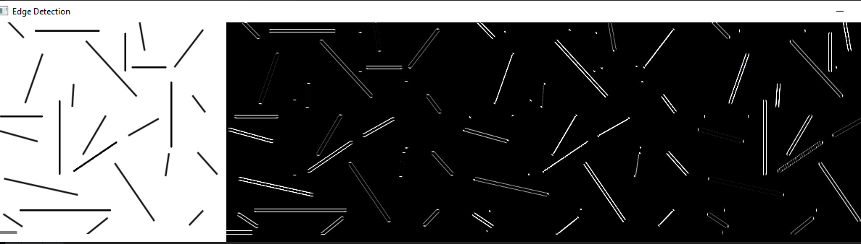

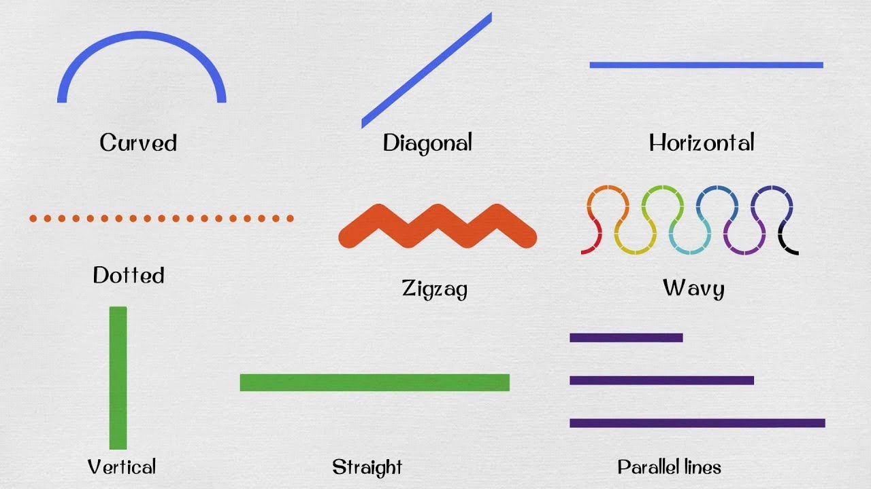

Procedure:

import cv2  
import numpy as np  
  
img = cv2.imread("curves.jpeg")  
img = cv2.resize(img, (0, 0), None, .25, .25)  
img = cv2.cvtColor(img, cv2.COLOR_BGR2GRAY)  
  
HorizKn = np.array(([[-1, -1, -1], [2, 2, 2], [-1, -1, -1]]), np.float32)  
Ng45Kn = np.array(([[2, -1, -1], [-1, 2, -1], [-1, -1, 2]]), np.float32)  
VertiKn = np.array(([[-1, 2, -1], [-1, 2, -1], [-1, 2, -1]]), np.float32)  
Ps45Kn = np.array(([[-1, -1, 2], [-1, 2, -1], [2, -1, -1]]), np.float32)  
  
HorizBlur = cv2.filter2D(src=img, kernel=HorizKn, ddepth=-1)  
Ng45Blur = cv2.filter2D(src=img, kernel=Ng45Kn, ddepth=-1)  
VertiBlur = cv2.filter2D(src=img, kernel=VertiKn, ddepth=-1)  
Ps45Blur = cv2.filter2D(src=img, kernel=Ps45Kn, ddepth=-1)  
  
horizStck = np.concatenate((img, HorizBlur, Ng45Blur, VertiBlur, Ps45Blur), axis=0)  
  
cv2.imwrite("Output.jpg", horizStck)  
  
cv2.imshow("Edge Detection", horizStck)

Output:

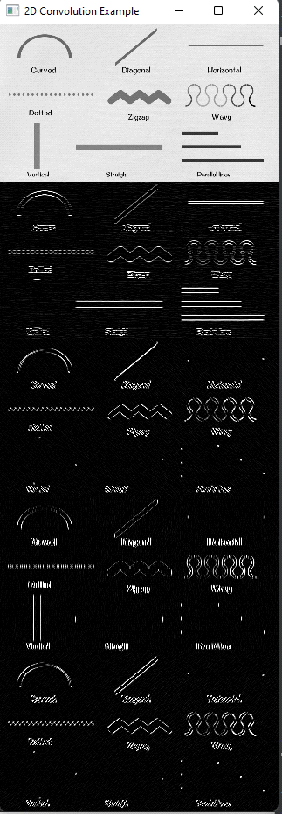

**Task 2**

Find the horizontal and vertical edges in the following picture. Display both horizontal, vertical and combined edges. Use a sobel filter. Implement both using the filter and the built-in function.

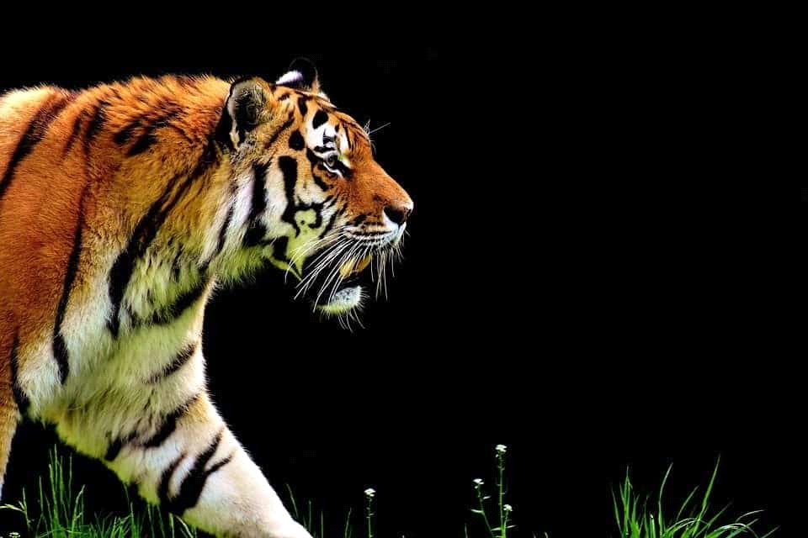

Procedure:

import cv2  
import numpy as np  
  
img = cv2.imread("tiger.jpg")  
img = cv2.resize(img, (0, 0), None, .5, .5)  
HorizKn= np.array(([[-1, -1, -1], [2, 2, 2], [-1, -1, -1]]), np.float32)  
Ng45Kn = np.array(([[2, -1, -1], [-1, 2, -1], [-1, -1, 2]]), np.float32)  
VertiKn = np.array(([[-1, 2, -1], [-1, 2, -1], [-1, 2, -1]]), np.float32)  
Ps45Kn = np.array(([[-1, -1, 2], [-1, 2, -1], [2, -1, -1]]), np.float32)  
SobelX = cv2.Sobel(img, cv2.CV_32F, dx=1, dy=0, ksize=3)  
SobelY = cv2.Sobel(img, cv2.CV_32F, dx=0, dy=1, ksize=3)  
  
cv2.imshow("sobelX", SobelX)  
cv2.imshow("sobelY", SobelY)  
SobelXY = cv2.Sobel(img, cv2.CV_32F, dx=1, dy=1, ksize=3)  
cv2.imshow("sobelXY", SobelXY)  
cv2.waitKey(0)  
cv2.destroyAllWindows()

Output:

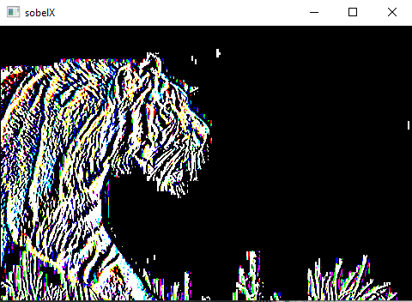

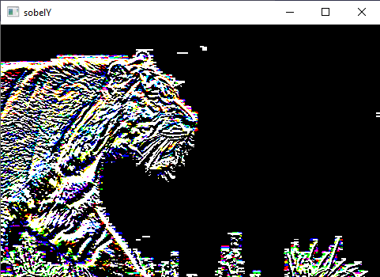

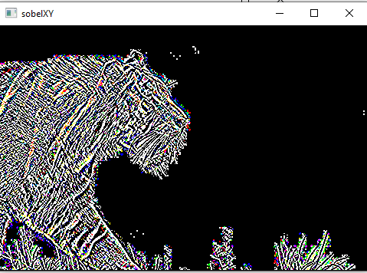

**Task 3:**

Read the image ‘coin’, you have to get the required output image shown in figure below. Analyze the input image and make the decision yourself what to do to get the required output.

Hint: Choose kernel/mask values yourself to get required output.

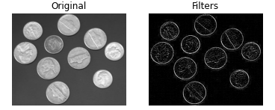

**Procedure:**

import cv2  
import numpy as np  
  
img = cv2.imread('coins.png')  
Lap_filter = cv2.Laplacian(img, ddepth=-1)  
img1 = np.concatenate((img, Lap_filter), axis=1)  
cv2.imshow("Laplacian image", img1)  
cv2.waitKey(0)  
cv2.destroyAllWindows()

**Output:**

